CSS Fonts and Font Family

First go to google fonts

<https://fonts.google.com>

then select your fonts and copy import

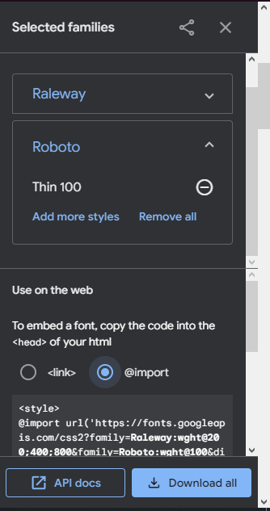

After Copy the imported style then past in the css file where you wanted to use the fonts